**Lab3 Submission**

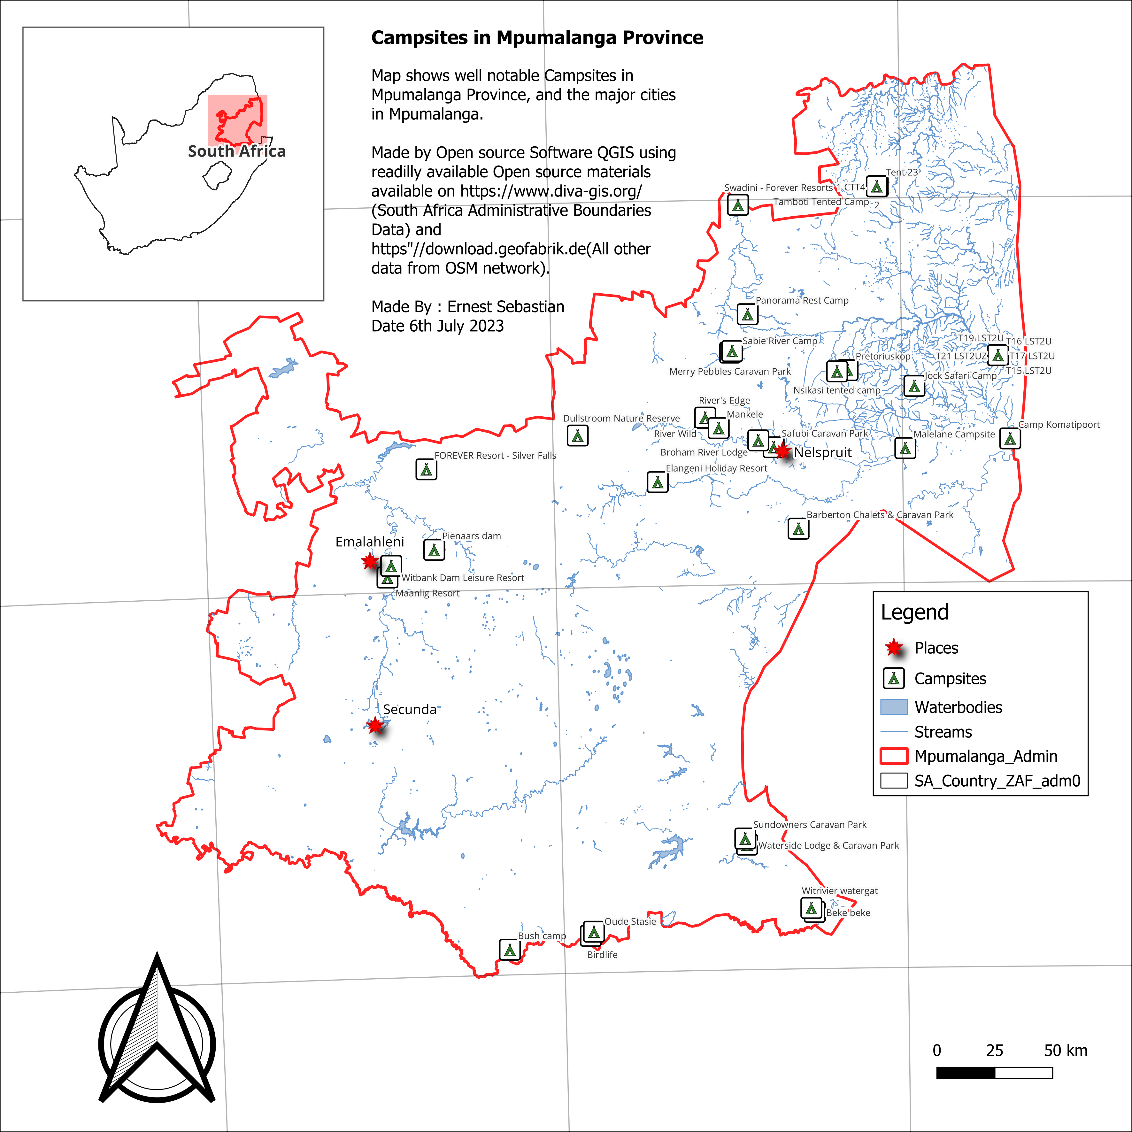

**Experience**

This project has opened my eyes and I can confidently say that I will continue trying until I do all the process without being given instructions.

At first looking at the large dataset, I had a feeling that I would not manage to achieve anything. But with the breaking down of it into smaller chunks, made this whole thing simpler.

What was a pinpoint was I spent over 2 hours trying to figure out why my Grid lines were slanted.

I then found out that it was because of CRS Chosen so after going back and looking at the instructions, I saw the one being used was the default ones, so I knew that wasn’t a problem.  
But I still wanted to make the lines as straight as they had to be.

Then after about 2 hours I went back to the final Map only to find out also that the result is the same. Mmmh weird I thought.

All in all, this has been fun to deal with, and I hope to explore more of this alone without any further guidance so to gain a deeper understanding of the process.